Name: _______________________________________________________________________ Period: __________

Chapter 1: KI-1 Reading Guide
Why is Geography a Science?

Geography is the study of where things are found on the earth's surface and the reasons for their locations. Geographers ask two simple questions: Where are people and activities found on the earth and why are they found there?

1.1.1: Summarize geography's basic concepts.

1. Explain three ways in which geographers collect data differently than historians.

a.

b.

c.

2. What is a geographer's most important tool?

3. What does the tool help explain?

4. Two basic concepts used by geographers are "place" and "region". What does each term explain?

a. Place:

b. Region:

5. What examples are used in the textbook to visually portray a place and a region?

a. Place:

b. Region:

6. Three basic concepts that help explain how different locations are interrelated are scale, space, and connection. Define each concept and explain the visual examples used in the textbook to help students understand each concept.

a. Scale:

Example:

b. Space:

Example:

c. Connection:

Example:

1.1.2: Explain the development of the science of cartography.

1. A map is a two-dimensional, flat-scale model of Earth's surface. A map serves two purposes. List each and explain at least two ways they are used.

a. __________________________________:

b. __________________________________:

1.1.3: Identify geography's principal contemporary mapping tools.

1. Electronic tools are very important for gathering and organizing geographic data. What five other methods do geographers still use to collect data? Why do you think these methods are necessary to gather accurate data?

2. What is geographic information science? How do geographic information systems (GIS) help geographers?

3. What is remote sensing?

4. What is Your HUMAN Geography? (see the inset on page. 9, problems 1 and 3).

#1: Mental Map | #3: Copy of Google or Bing Map

1.1.4: Explain the role of map scale and projection in reading maps.

1. Read page 10, and then study Figure 1-16. Starting at the top, review the following information:

Top Image
- Title:
- Ratio scale:
- Graphic scale (in miles):
- Compare the image to the other three on the page. On a scale of 1 to 4 (1 being the smallest scale map and 4 being the largest scale map), which ranking would you give this image and why?

Second Image
- Title:
- Ratio scale:
- Graphic scale (in miles):
- Compare the image to the other three on the page. On a scale of 1 to 4 (1 being the smallest scale map and 4 being the largest scale map), which ranking would you give this image and why?

Third Image
- Title:
- Ratio scale:
- Graphic scale (in miles):
- Compare the image to the other three on the page. On a scale of 1 to 4 (1 being the smallest scale map and 4 being the largest scale map), which ranking would you give this image and why?

Bottom Image
- Title:
- Ratio scale:
- Graphic scale (in miles):
- Compare the image to the other three on the page. On a scale of 1 to 4 (1 being the smallest scale map and 4 being the largest scale map), which ranking would you give this image and why?

2. What is the advantage of using a large-scale map (one which shows only a small portion of the earth's surface, like a neighborhood)?

3. What is the advantage of using a small-scale map (one which shows a large portion of the earth's surface, like a continent or the whole world)?
4. When geographers convert the round sphere of Earth to a flat map, they use a projection. All projections have some distortion (only a globe has none). List four things that typically become distorted in map projections.

a.

b.

c.

d.

5. Two important map projections are the Winkel and the Mercator. Complete the chart to compare advantages and disadvantages.

 |  | WINKEL | MERCATOR
Advantages
Disadvantages

6. Using the four map projections on page 11, compare the sizes of Greenland and South America. Which of the two landmasses is actually larger? How do you know?

1.1.5: Explain how the geographic grid locates points on Earth's surface.

1. Label the following on the map: equator, prime meridian, a “parallel”, and a “meridian”, a line of latitude and a line of longitude.

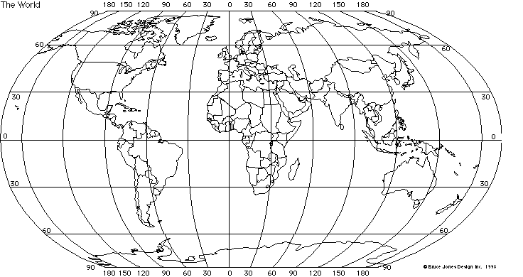
2. Using the map shown in #1, name the country, or U.S. state found at the intersection of the following lines of latitude and longitude (one answer will be a continent).
a. 60°N 150°W: _____________________________________________________________
b. 30°S 120°E: _____________________________________________________________
c. 85°S 90°W: _____________________________________________________________
d. 75°N 30°W: _____________________________________________________________

3. Read the information and study the diagrams on page 13. It outlines five types of maps often used in AP Human Geography. Without referring to the reading, label each type of map shown below.
- Cartogram
- Choropleth map
- Isoline map
- Graduated symbol map
- Dot distribution map

Type of Map: | Type of Map:
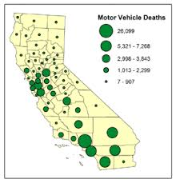 | 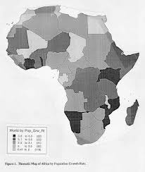
Type of Map: | Type of Map:
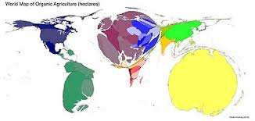 | 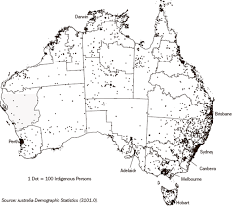
Type of Map:
